SWE 602 Software Requirements Elicitation

Software Requirements Specification Document - Vision 2020

Team Dracarys

Mounika Reddy Jaladanki - 94976
Pavani Eupuri - 94850
Shruti Sankhe - 94964
Vimarsha Adyar - 94703

Version: 1.0 Date: (04/12/2020)
Table of Contents
1. Introduction 3
1.1. Purpose 3
1.2. Scope 3
1.3. Definitions, Acronyms, and Abbreviations. 3
1.4. Resources & References 4
1.5. Overview 4
2. The Overall Description 4
2.1. Stakeholder Interviews 5
2.2. Product Perspective 8
2.2.3. Software Interfaces 16
2.2.4. Communications Interfaces 16
2.2.5. Operations 16
2.2.6. Site Adaption Requirements 17
2.3. Product Functions 17
2.4. User Characteristics 32
2.5. Assumptions and Dependencies 33
2.6. Apportioning of Requirements 33
3. Specific Requirements 33
3.1. Functional Requirements 34
3.2. Performance Requirements 36
3.3. Software System Attributes 37
3.3.1. Availability 37
3.3.2. Security 38
3.3.3. Data Consistency 39
3.3.4. Scalability 40
3.4. Functional Hierarchy 41
3.5. Requirements Validation 42
4. Change Management Process 43
5. Document Approvals 43

- Introduction
Ophthalmology is a science of studying medical conditions associated with eyes. Vision 2020, a healthcare solution, which will cater to the operational business requirements of the ophthalmology clinics.

  - Purpose
The Ophthalmologists have difficulties to manage their patients’ data and offer them the best time for the next appointments by using historical patients' data. Vision 2020 is a software system for Ophthalmologists and the clinic staff to manage their patients’ information and schedule appointments.

  - Scope
Vision 2020 aims to streamline maintaining reports, acquiring consents, organizing, searching and reporting patient data, printing ledgers, scheduling treatments and receiving patients’ feedback.
We will also try to evaluate possible risks of operating a healthcare software, like data inconsistency, security, maintenance, extendibility of a system.

  - Definitions, Acronyms, and Abbreviations.
Ophthalmologist is an expert in diseases, functions and anatomy of the eye. They provide routine care such as vision testing as prescribe and fit eyeglasses or contact lenses and are also surgeons. They repair traumatic injuries to the eye and perform cataract and corneal surgery.

Optometry is the practice or profession of examining the eyes for visual defects and prescribing corrective lenses

Insurance Claim is a formal request by a policyholder to an insurance company for coverage or compensation for a covered loss or policy event. The insurance company validates the claim and, once approved, issues payment to the insured or an approved interested party on behalf of the insured.

Micro services are smaller discrete set of services that are focused on 1 or 2 functions and the lines of division between them are very clear using APIs and the development teams are only focused on their area of responsibility.

  - Resources & References

- Software Engineering 10th edition by Ian Somerville
https://dinus.ac.id/repository/docs/ajar/Sommerville-Software-Engineering-10ed.pdf
- Software Requirements 3rd edition by Karl Wiegers and Joy Beatty
https://ptgmedia.pearsoncmg.com/images/9780735679665/samplepages/9780735679665.pdf
- Stakeholder Identification and Categorization
https://www.pmi.org/learning/library/secure-360-stakeholder-buy-in-9306
- The Unified Modeling Language Reference Manual
http://www.temida.si/~bojan/IPIT_2014/literatura/UML_Reference_Manual.pdf
- Trello Project Management
https://trello.com/b/3VDJUQgy/vision2020
  - Overview
The intended audience of this document would be the Project Manager, the development team, client side employees like Ophthalmologists, Junior doctors, and Clinic staff with the objective to refer and analyze the information. This SRS document can be used in any case regarding the requirements of the project and the solutions that have been taken. The document would provide a clear idea about the system that is building.
Customers/potential users care about section 2, developers care about section 3.

- The Overall Description
The development of Vision 2020 is planned to finish in four phases. The first phase will focus on identifying stakeholders, defining functional and non-functional requirements, designing system architecture and UML diagrams. Second phase will focus on building system prototypes, product development and code, risk management and software quality reports. Third phase will focus on project demo testing. Finally the fourth phase will aim to present prototype demo to end users.

Action Items | Deadline
Project abstract & Purpose | 01/13/2020
Project plan and schedule | 01/26/2020
Identifying & Working with Stakeholders | 02/07/2020
Product Perspective | 02/14/2020
Product Functions & UML diagrams | 03/18/2020
Functional & Non-Functional requirements document | 03/27/2020
System Prototype | 03/27/2020
Final project report | 04/12/2020

  - Stakeholder Interviews
The following stakeholders have been identified for the system:
Acquirers - End-users who directly or indirectly use the product
  - Ophthalmologists
  - Junior doctors
  - Clinic staff
  - Patients
Suppliers – Team involved in development and distribution of the product
  - Project manager
  - Developer(Frontend, backend)
  - Ui Designer
  - System architect
External agency
  - The Representative of American Academy of Ophthalmology
  - The association for auditing individual ophthalmologist
  - Insurance provider

- Individual Interview Questions for Experienced Ophthalmologists
For insightful information from our clients regarding market trends and funds, our interview procedure will comprise of questions mentioned below:
- Introduction of both the parties and purpose of visit
- Understand the practical scenarios and expectations from the project
- Listening to the detailed feedbacks

- What are the issues we are expected to resolve?
We need a system to schedule/reschedule appointments, treatments, prescribe medicine, suggesting future treatments, analyze and research health history. A flexible system that incorporates ways of every ophthalmic surgeon and staff. A highly secured system strictly abiding to the laws and regulations related to the health data.

- What would be the ideal result of this project?
To be used by every ophthalmology clinic and optician office.

- How to achieve these results?
Effective and precise collection and prioritizing of requirements from ophthalmologists and staff. Formulation of a detailed project plan. Technical team with strong skills for successful implementation in arenas like backend, frontend, security and design.

- What are the critical factors for the project to be successful?
Incorporating requirements of both the parties i.e. doctors and patients. Promising ease of access and increase in productivity. Get the required funding by presenting the statistical data to stakeholders by building confidence.

- What would be the hindrances on the path towards a successful outcome?
Multiple scenarios can take the project downhill for example, hiring an inefficient team to handle the security. It can lead to loss of trust in the market. Insufficient funds may lead to building a team that lacks the required skill-set which may lead to project failure.

- End-User Survey
The below questionnaire is considered to send the end users to collect their feedback.
- What issues can Vision 2020 software help you with?
  - Check patient records for upcoming appointments, send notifications for schedules and feedback
  - Retrieving historical health data
  - Scheduling and rescheduling appointment times
  - Suggestive treatments based on patients’ historical health data
  - Your suggestions:

- Any user interface challenges you want Vision 2020 to tackle?
- Availability of patient’s data and prescription history
- Minimum parameters or attributes for data retrieval
- Data backup
- Your suggestions:
- Any security concerns about Vision 2020?
- Patient data compromised
- Data leaks via web access
- Unsecured financial transactions
- Your suggestions:

- What is the main objective of storing patient data?
- Easy data availability
- Convenient data retrieval and exchange
- Enabling historical analysis
- Your suggestions:

- Brainstorming sessions with target audience
Brainstorming is a group creativity technique available for eliciting requirements from stakeholders. It encourages participants to think more freely and suggest as many spontaneous new ideas to be included in the product we are developing.
Below are the sequence of activities the team has planned for successful brainstorming:
Step 1: Prepare the Group
- The team targets 5 events of 2 hours each with 10 participants in each brainstorming session
- Secondly, set up a comfortable meeting environment for the session, decide upon a time and invite the respective groups
- Upon gathering, everyone introduces themselves

Step 2: Present the Problem
- The team clearly defines the problem and the criteria they must meet, while making it clear that the meeting's objective is to generate as many ideas as possible.
- Give participants plenty of time at the start of the session to write down as many of their own ideas as they can. Then, ask them to share their ideas, while giving everyone a fair opportunity to contribute.

Step 3: Guide the Discussion
- Once everyone has shared their ideas, start a group discussion to develop other people's ideas, and use them to create new ideas
- As the group facilitator, ask the following questions
- What systems are you currently using?
- What are the challenges you are facing as an Ophthalmologist with your day to day operations?
- Are you facing any challenges with the current system?
- Is the current system easy to navigate and user friendly? Do you have any preferences?
- Is the current system accessible from all devices?
- Are there any specific suggestions you would like to put forward to have a better experience?
After the brainstorming activity is completed, the team will discuss and evaluate each idea raised during the event. This includes grouping similar ideas and prioritizing some vital ideas.

  - Product Perspective

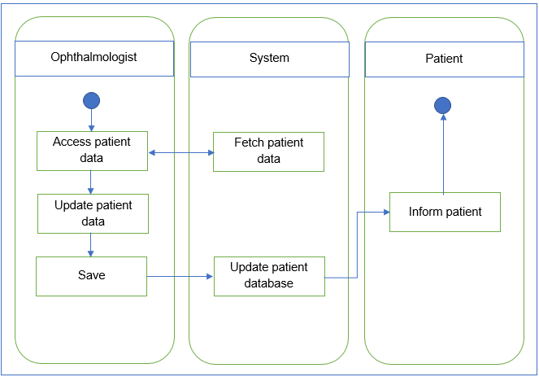

    - Interfaces
The system will interact with its users using a GUI. It will have various sections and quick links for the users of the system to perform various actions. The system will be HIPAA compliant.
- Vision 2020 Main Dashboard
Main categories include:
- Patients
- Doctors
- Appointments
- Billing & Collections
- Reports
Quick Links tab on the right side of the screen will provide quick access to the most accessed functionalities.
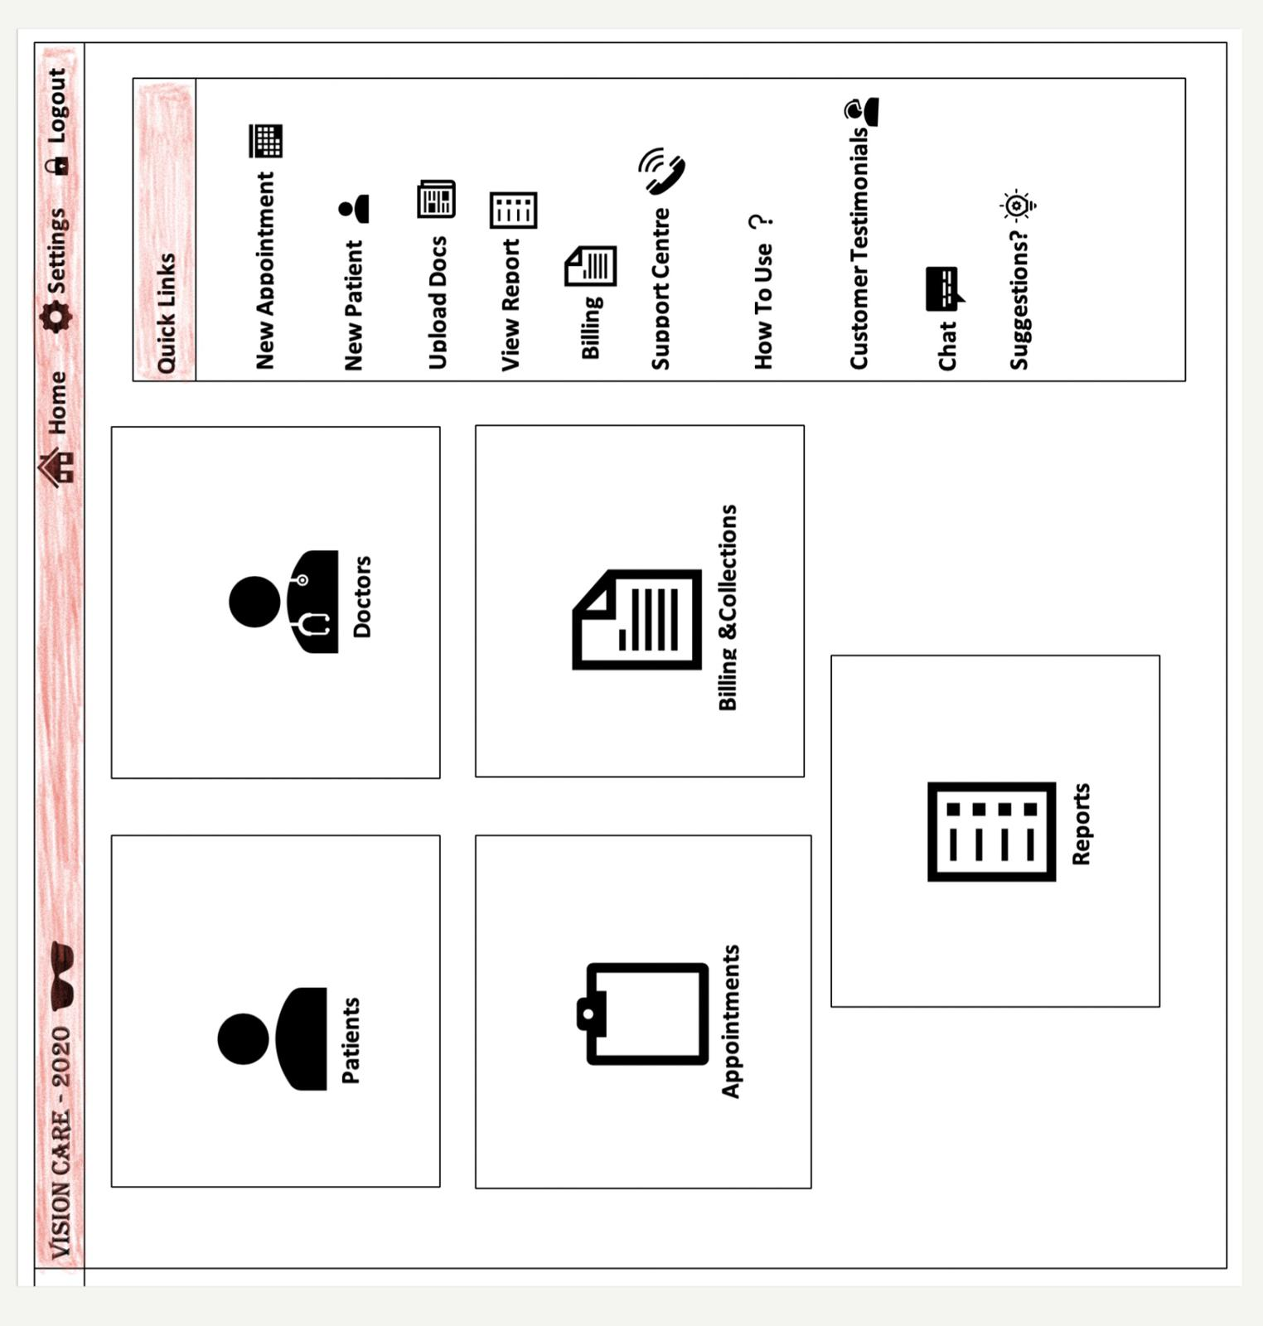

New Patient Creation Dashboard

This dashboard is used to create new patient profiles for the ophthalmology clinic and can be navigated to upon clicking the ‘Patients’ category on the Main dashboard or the ‘New Patient’ link from the Quick Links tab. The clinical staff is responsible for collecting all the necessary information like Name, DOB, blood group, mobile no, email, allergic information, purpose of visit etc. from new patients and create the new Patient record using the below shown dashboard.
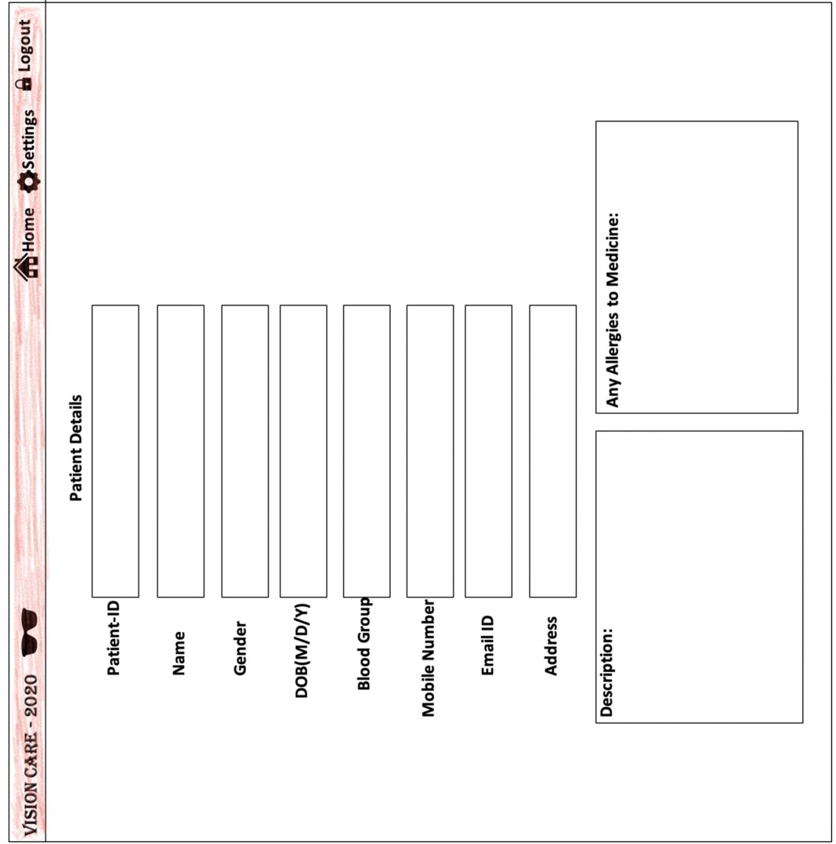

View/Search Existing Patient Profile

The below dashboard is a prototype of how an existing patient profile would appear on the system screen. This can be navigated to upon clicking the ‘Patients’ category on the Main dashboard. This dashboard will have all the information about the patient, history of visits, concerns/problems, medications, reports and test results.

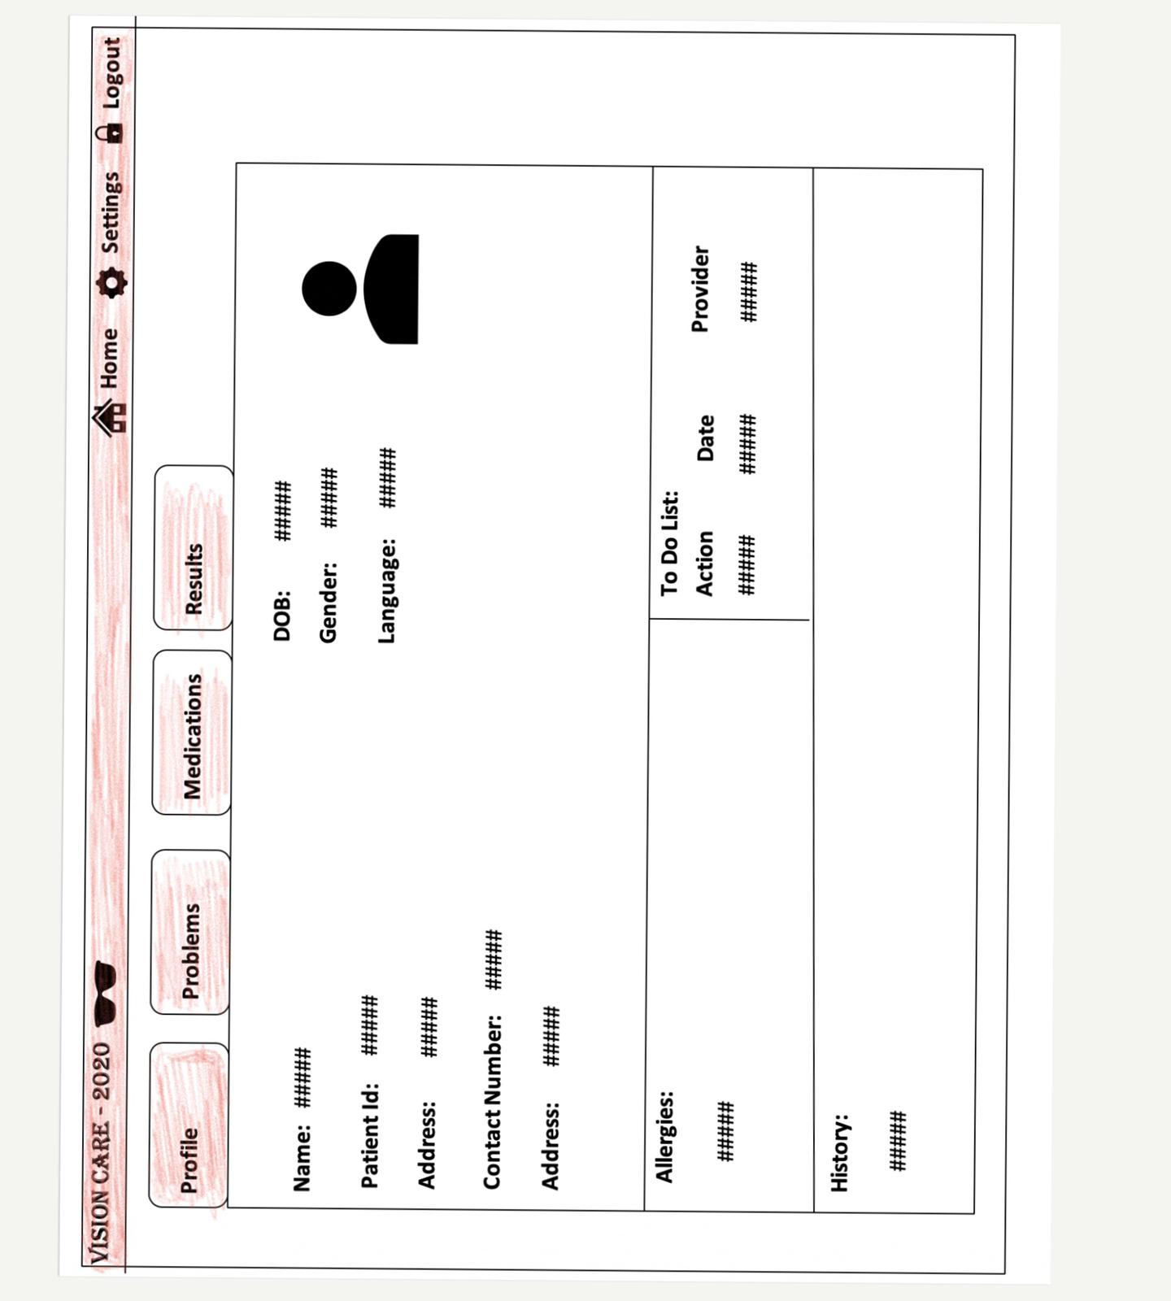

Doctor’s Profile View

The below dashboard is a prototype of how an Ophthalmologist’s profile would appear on the system screen. This can be navigated to upon clicking the ‘Doctors’ category on the Main dashboard. This dashboard will contain information about the ophthalmologist’s mini biography, education, expertise, reviews and all of his/her scheduled appointments in the clinic.
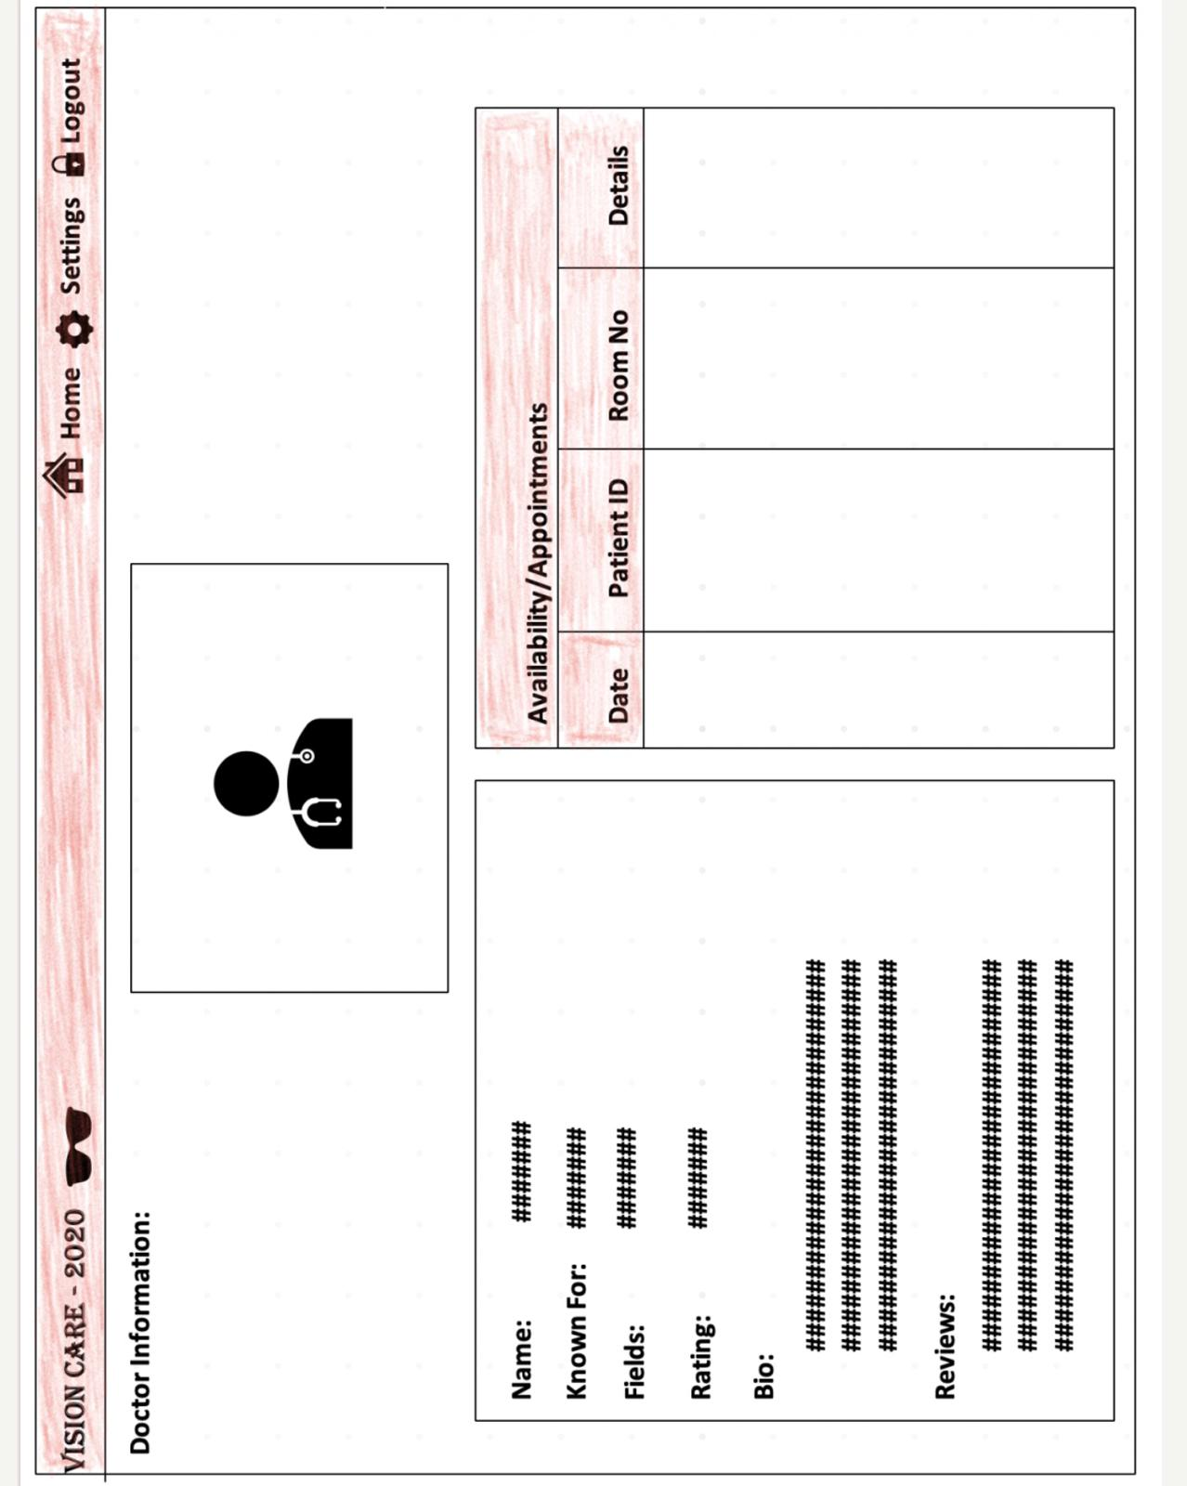

Appointments Dashboard

The below prototype is a reflection of how the Appointment creation window would appear on the system. This window will appear upon clicking on the ‘New Appointment link from the Quick links tab or by selecting the Appointments category from the main dashboard. Other options include viewing all existing appointments, updating or cancelling an existing appointment.

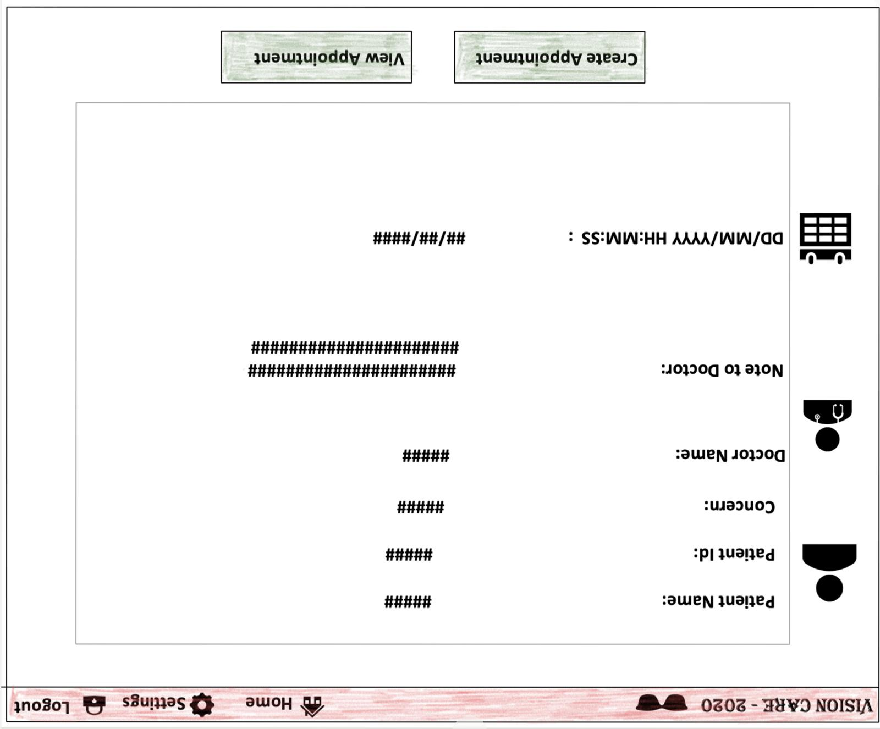

Billing and Collections Dashboard

All transactions between patient and the clinic and other third parties can be viewed on the Billings dashboard. This dashboard will also contain links to view Insurance claims and Invoices for the balance amount to be paid by the patients.
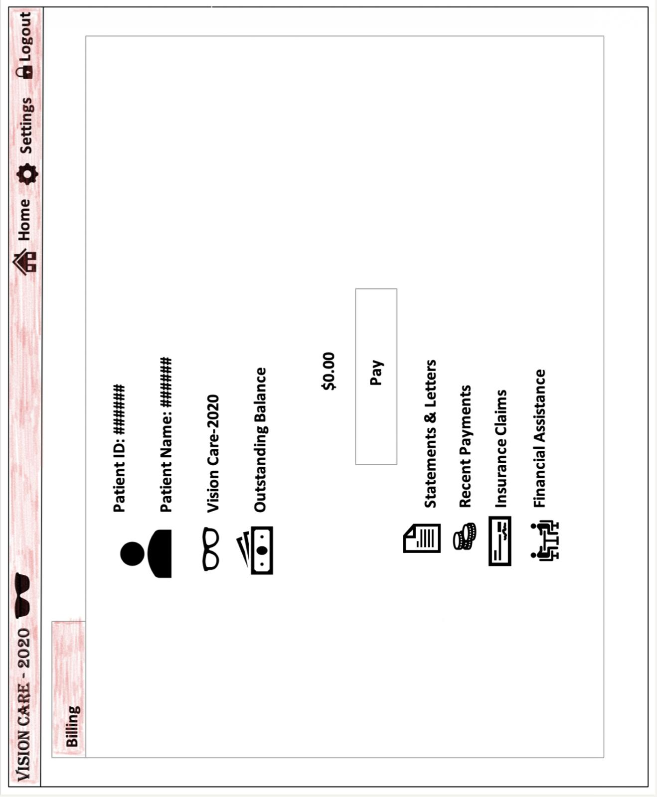

Reports Dashboard

All the applicable diagnosis reports and test results from in-house laboratories will be displayed on this dashboard. Each file can be downloaded and saved upon clicking on the file name.
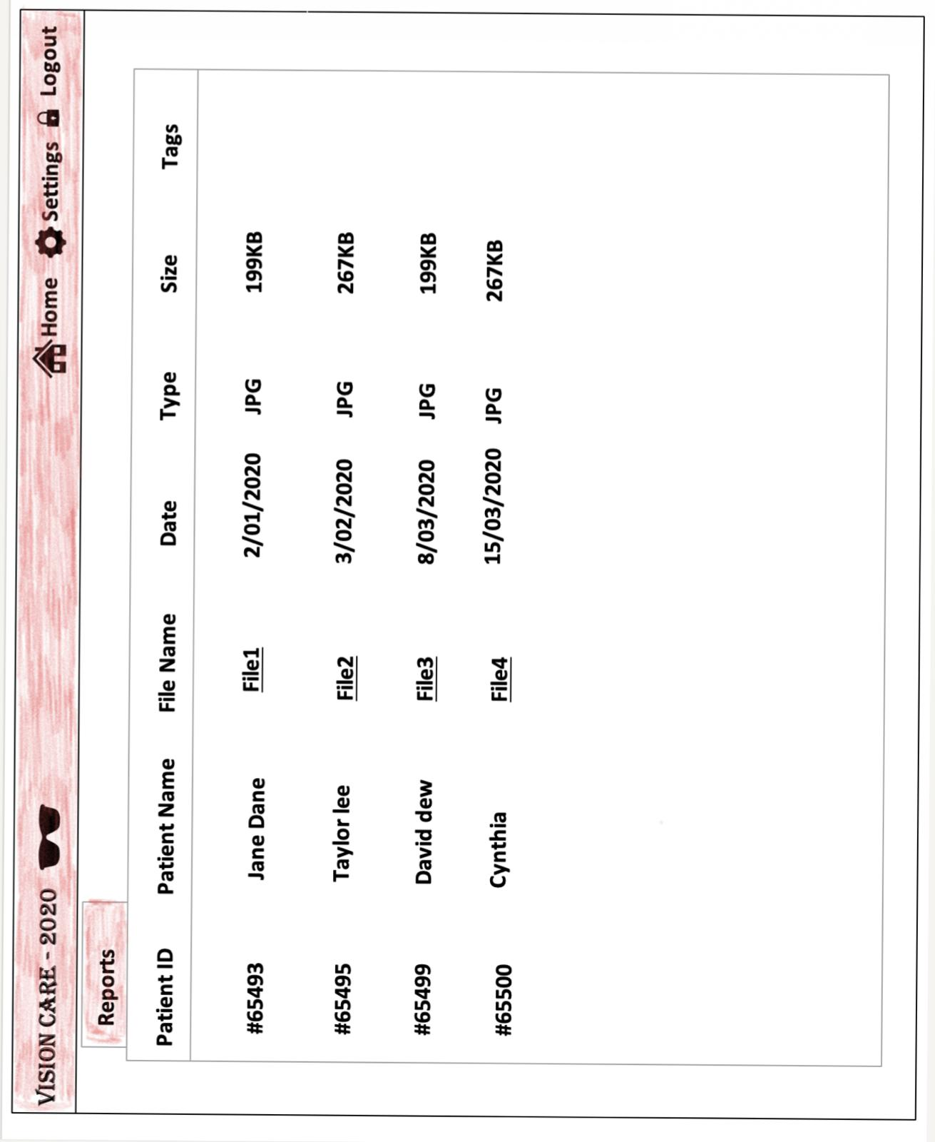
    - Hardware Interfaces

Laptop/Desktop PC:
- core i5 processor
- 4GB RAM
- 500GB HDD

Purpose of this pc is to run the Vision2020 applcation and perform all operations such as entering/accessing/searching details.To perform such action, this system needs to be efficient, otherwise due to that reason patients have to wait for a long time to get what they ask for.

Laser Printer (B/W)
Simply this device is for printing bills and view reports.

Wi-Fi router
Wi-Fi router is used to for internetwork operations and data transmission from pc’s to sever.
    - Software Interfaces
This will be an on-premise application connected to the database on cloud server and a backup database on the local server. Upon trying to input or access any information to and from the system, the system shall communicate with the database on the cloud to store/retrieve information. In case of network irregularities, the system will automatically try to connect to the local database which is the exact replica of the database on the cloud server. Upon network reconnectivity, the new data will sync back with the cloud database.

Developing end
- JDK 1.8 - Java is fast, secure, and reliable.
- Netbeans 8.1 - IDE for Java developing.
- Oracle - Database connectivity and management. The system must use Oracle12c as its database component. Communication with the DB is through ODBC connections. The system must provide oracle data table definintions to be provided to the company DBA for setup.
- Adobe Photoshop cs4 - Logo and other designing such as User interfaces

Client End
- OS – Windows 7/8/8.1- Very user friendly and common OS
- JRE 1.8 - JAVA Runtime Environment for run Java Application and System
- Oracle - Database connectivity

    - Communications Interfaces
- NIC (Network Interface Card) – It is a computer hardware component that allows a computer to connect to a network . NICs may be used for both wired and wireless connections.
- TCP/IP protocol – Internet service provider to access and share information over the Internet.
- Ethernet Communications Interface- Ethernet is a frame-based computer network technology for local area networks (LANs)

    - Operations
- Data processing support functions required to be performed by the user:
- Clinic staff create new patient profiles
- Clinic staff search/update patient profile data
- Ophthalmologist/Clinic staff access/create/cancel/reschedule patients’ appointments
- Clinic staff acquire patient consent for treatments
- Clinic staff Validates Insurance Coverage and Generates Invoice
- Clinic staff send emails/text to patients to remind them of upcoming appointments
- Clinic staff collect feedback/survey from patient

- Backup and recovery operations are:
- System should be monitored for user activity
- System maintenance should be carried out during least activity slots
- System users should be notified about the downtime

    - Site Adaption Requirements
A local DB server and a cloud server should be set up and the new data tables created for this system must be installed on both the servers and populated prior to system activation. Both the local and cloud databases should be synchronized in order to avoid data inconsistency.

  - Product Functions

- Clinic staff creates new patient profiles
Goal: This function focuses on creation of profiles for new patients. This function is used by the ophthalmology clinic employees to create new patient data for the data records.

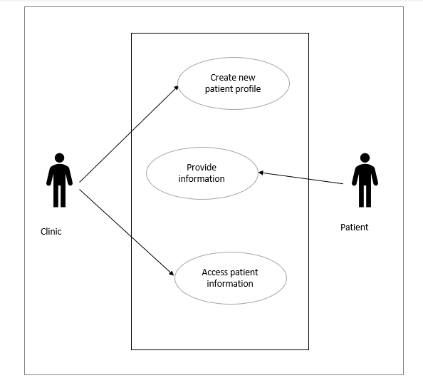

Identifier | UC_001
Name | Create new patient profile
Trigger | Creating profiles for patients visiting the clinic for the first time
Preconditions | Check for existing profiles for the patient.  Patient should have valid identification documents
Postconditions | A profile with the personal and contact details of the patient
Primary actor | Clinic staff/ Receptionist
Participants (secondary actors) | Patient
Related use cases | N/A
Description of events | - A clinic employee accesses new form to enter the patient’s data  - They enter the data provided by the patient in the appropriate fields  - The data is validated and verified by the system  - The data is submitted and stored in the system  - 5. A message is shown after successful submission of the data

- Clinic staff search/update patient profile data
Goal: The clinic staff should be able to search the patient records and update patient information, such as diagnosis, suggested medication, referrals, health conditions, treatments and prescriptions.
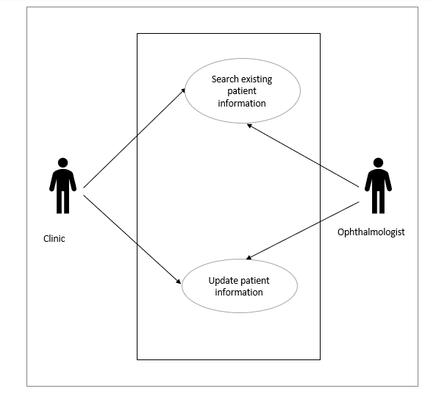
Identifier | UC_002
Name | Search/update profile data of the patient
Trigger | The staff searching for the existing profile of the patient  The staff updating the existing profile of the patient
Preconditions | Patients’ record must exist in the application
Postconditions | The search function must return the profile as a result for an existing patient.  The search function must return no result for a new patient.  The changes made to update a profile must be validated.  The changes made to the profile must be saved after the form submission.
Primary actor | Clinic staff, Ophthalmologists
Participants (secondary actors) | Patient
Related use cases | N/A
Description of events | - A clinic employee searches patient’s data  - They find the patient profile associated with the search keywords  - The data is validated and verified before updating by the system  - The data is submitted and stored in the system  - 5. A message is shown after successful submission of the data

- Ophthalmologist/Clinic staff access/create/cancel/reschedule patients’ appointments
Goal: In this scenario, the Staff/Receptionist at the ophthalmology clinic shall be able to access the patient’s current appointments if any and book new appointments or cancel/reschedule existing appointments as per patient’s request. If there is an update to the appointment, automatic email and text message are triggered to inform the patients.
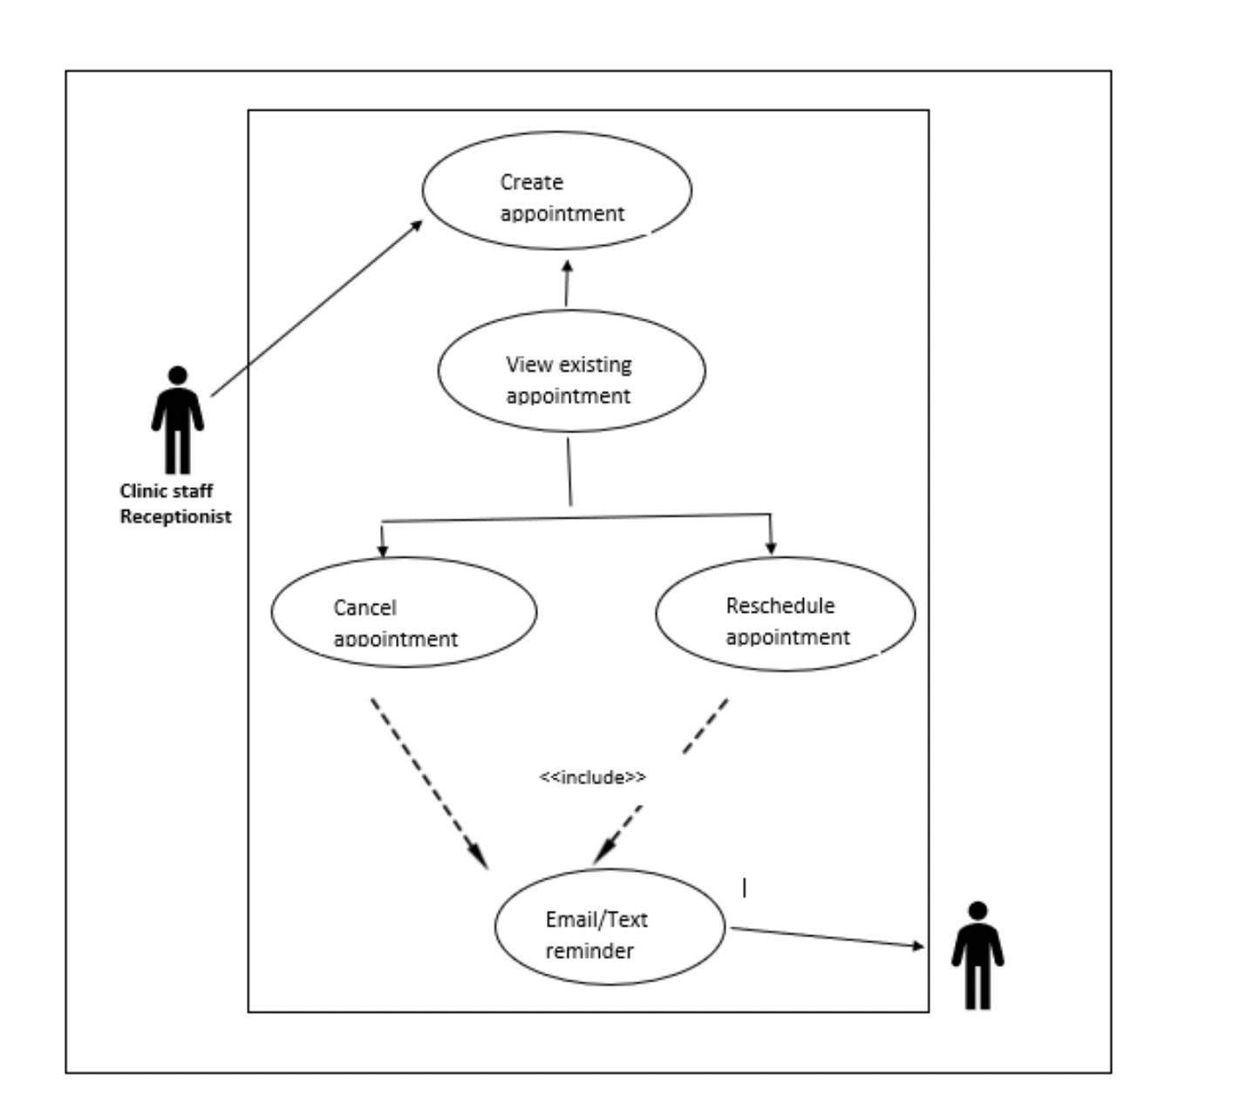

Identifier | UC_003
Name | Access/create/cancel/reschedule patients’ appointments
Trigger | As per patient’s request, the Clinic staff/Receptionist want to access/create/cancel/reschedule their appointments
Preconditions | Patient record must exist on the application
Postconditions | Clinic staff/Receptionist can view the changes they have made to the appointments
Primary actor | Clinic staff/Receptionist
Participants (secondary actors) | Patient
Related use cases | UC_007
Description of events | - A Clinic staff/Receptionist can find the patient’s existing appointment information in the system with date/time mentioned  - Clinic Staff / Ophthalmologist Should be able to select an appointment from the list.  - Clinic Staff / Ophthalmologist should be able to book an appointment for a particular date and time if there is no existing appointment  - Clinic Staff / Ophthalmologist should be able to update an existing appointment information and cancel/reschedule to a different date. An update triggers an email/text message sent to the patients

- Ophthalmologist/Clinic staff upload documents
Goal: In this scenario, the Ophthalmologist/Clinic staff at the ophthalmology clinic shall be allowed to upload applicable diagnosis reports or tests to the patient profile.
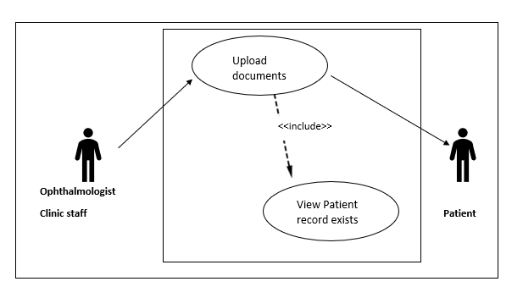
Identifier | UC_004
Name | Upload documents
Trigger | If there is any diagnosis reports or tests available, the Ophthalmologist/Clinic staff shall upload them to the patient profile for reference
Preconditions | Diagnosis reports or tests must be available
Postconditions | Ophthalmologist/Clinic staff are able to view the uploaded documents
Primary actor | Ophthalmologist/Clinic staff
Participants (secondary actors) | Patient
Related use cases | UC_002
Description of events | - Patient undergoes applicable diagnosis  - The reports get available and the Ophthalmologist/Clinic staff uploads them to the patient’s record  - The reports shall be viewed in the patient’s record

- Clinic staff Acquire Patient Consent for Treatment/Surgery
Goal: In this scenario, the Staff/Receptionist at the ophthalmology clinic takes a digital signature as a form of consent from the patient for the scheduled treatment/surgery.
This can be achieved in two ways:
I. Patient is physically present at the clinic and signs the consent form using the electronic signature panel.
II. Clinic staff/Receptionist emails the consent form to the patient to acquire consent in the form of digital signature.

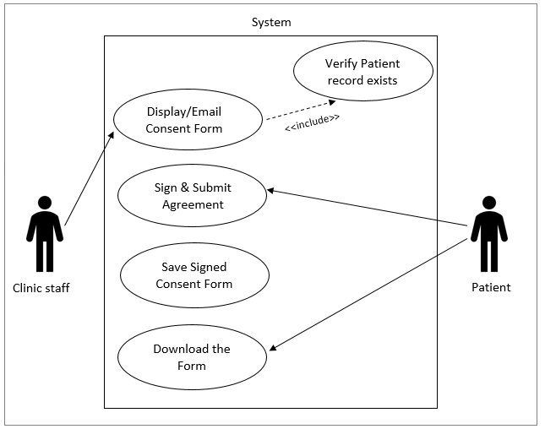

Identifier | UC_005
Name | Acquire Consent
Trigger | Clinic staff want to take consent from the patient before the treatment/surgery
Preconditions | Patient record must exist on the application
Postconditions | Patient shall sign and submit the form and be able to view it later
Primary actor | Clinic staff/ Receptionist
Participants (secondary actors) | Patient
Related use cases | UC_002
Description of events | - System displays all the responsibilities and agreements between the patient and the doctor  - Patient reads the agreement and signs it  - System saves the form  - Patient downloads the form

- Provider Validates Insurance Coverage and Generates Invoice
Goal: In this scenario, the system looks up the patient’s medical insurance coverage, calculates the deductible to apply claims and generates an invoice for the balance amount to be paid by the patient.
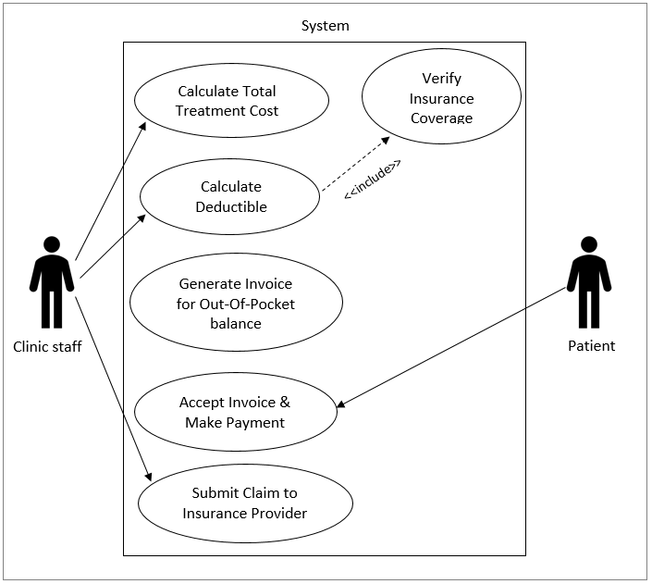

Identifier | UC_006
Name | Generate Invoice
Trigger | Ophthalmologist/Clinic staff want to generate invoice for patient’s treatment/surgery
Preconditions | Patient record must exist in the system
Postconditions | - Patient accepts invoice and makes payment  - Clinic submits claim to the Insurance provider
Primary actor | Ophthalmologist/Clinic staff
Participants (secondary actors) | Patient, Insurance Provider
Related use cases | UC_002
Description of events | - Clinic Staff initiates Bill Generation for Patient’s service using billing application  - System validates Patient’s existing insurance details from its records  - System determines services covered under insurance policy and calculates eligible deductibles to apply for claims to the insurance provider.  - System generates invoices for out-of-pocket balance to be paid by the patient.  - Patient accepts the invoice generated and the amount covered by the insurance policy.  - Patient makes payment for an out-of-pocket balance amount.  - Clinic System submits claim details to Insurance Providers.

- Clinic staff send emails/text to patients to remind them of upcoming appointments
Goal: In this function, a Clinic Staff / Receptionist creates notifications for patients’ appointments. By creating notification via emails/texts, the Clinic staff can remind the patient about upcoming appointments before the appointment time.
Options are: 15 minutes before appointment, 30 mins, 45 mins, 1 hour, 2 hours, 4 hours, 12 hours, 24 hours, and 48 hours.
By setting notifications or reminders before appointments, clients can schedule their time and work for this appointment, if they can’t attend this meeting they can postpone or prepone according to their time/work.

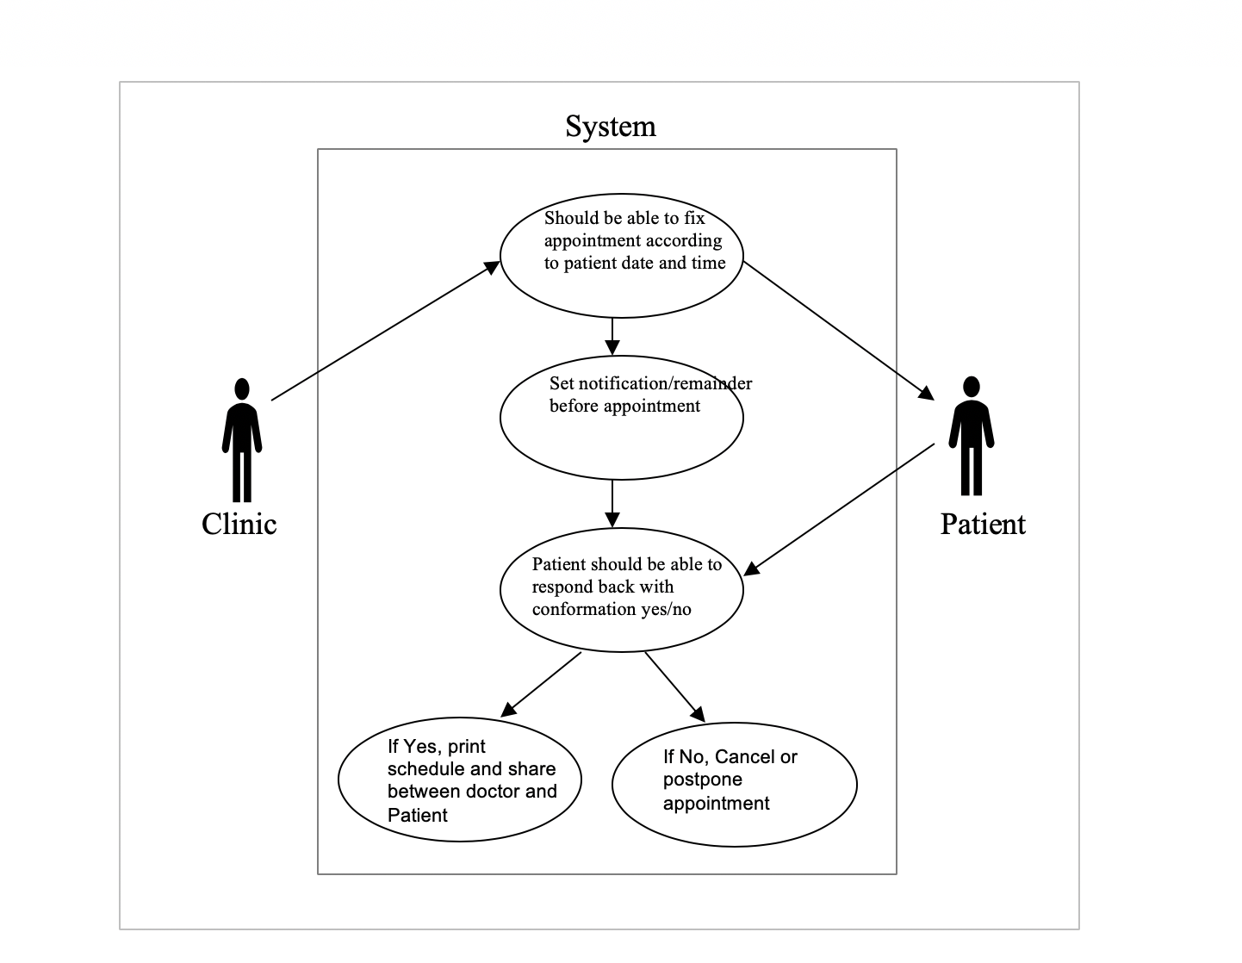

Identifier | Create UC-007
Name | Send Notification/Reminder
Trigger | Clinic staff wants to create notifications via Email, SMS, Phone call to remind patients’ of their upcoming appointment
Pre-condition | There Should be an existing appointment.
Post- Condition | - Appointments are viewed.  - An update may occur.  - Update triggers email/ text messages
Primary Actor | Clinic staff/ Receptionist
Participants (secondary actors) | Patient
Related use cases | UC_003
Description of events | - Clinic staff / Ophthalmologist should be able to reach patient’s account  - Clinic Staff / Ophthalmologist should see available appointments with date/time mentioned by the client.  - Clinic Staff / Ophthalmologist Should be able to select an appointment from the list.  - Clinic Staff / Ophthalmologist should be able to book an appointment for a particular date & time.  - Clinic Staff / Ophthalmologist should ask Patient that” Are they willing to set a Notification/ Reminder for their upcoming appointment”  - Clinic Staff should be able to set a notification/ reminder for their upcoming appointment.  - Patients should be able to respond back to notification with confirmation yes or No.  - If yes, Clinic staff should be able to print schedules and share between Ophthalmologist and Patient.  - If No, Clinic staff should be able to cancel or postpone appointments.

- Clinic staff/Ophthalmologist collect feedback/survey from patient
Goal: In Ophthalmic practice the maintenance and restoration of visual function is the ultimate goal. General purpose of patient feedback surveys is information about how satisfied your patient are with different aspects of your service/product and about general experience they had with your clinic. This information can be collected in different kinds of surveys like promoted feedback. Unpromoted feedback-we can find opinions and reviews of clients post online by using internet monitoring tools.
In this scenario, a patient opinion is a resource for improvising patient experience and adjusting actions to patient needs. A Clinic Staff / Ophthalmologist Conducts a feedback survey to assess the awareness of the existence of health-related quality of life (QOL), Thoughts, Opinions, and Feelings and for any suggestions. In this survey hospital-level characteristics, electronic health services, abstracted clinical information can be known. Collecting patient feedback shows you value their opinions. Patient feedback helps you create the best customer experience patient feedback helps to improve customer retention.
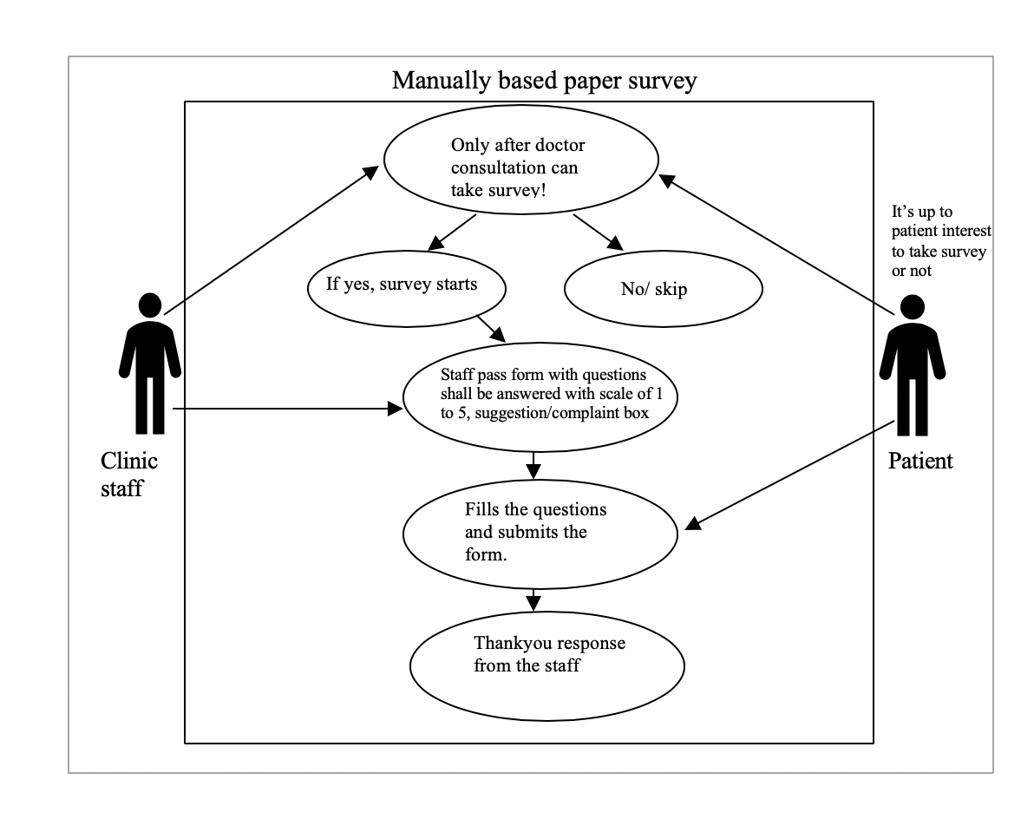
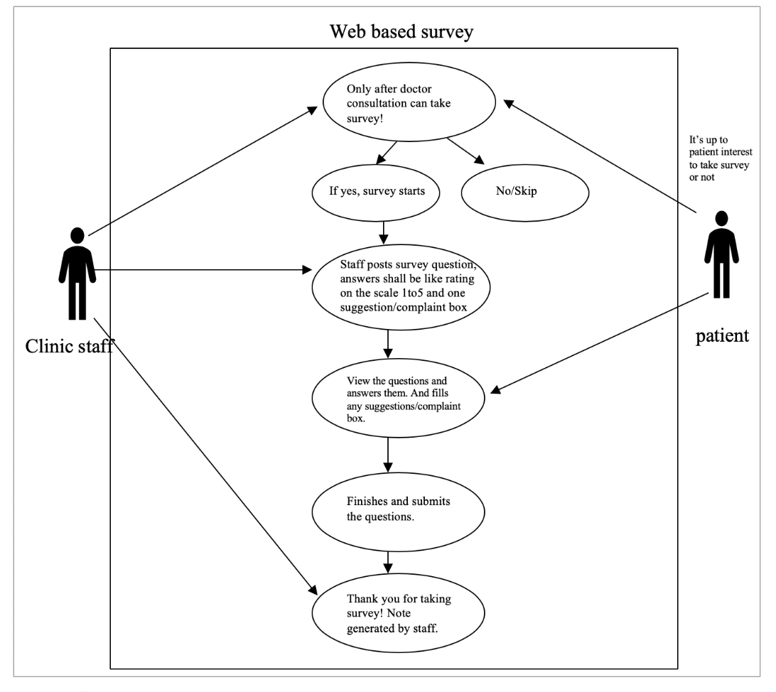
Identifier | Create UC_008
Name | Collect Patient Survey/Feedback
Trigger | Ophthalmologist/Clinic Staff want to collect patient opinion about how satisfied the patient was with different aspects of the service and their general experience at the clinic.
Pre-condition | Surveys should take place once a patient has his/her treatment or consultancy with clinic staff/Ophthalmologist.
Post- Condition | - Patient agreeing to take a survey is not compulsory.  - An update may occur.  - According to answers, service may change from next visit.
Primary actor | Clinic staff/ receptionist
Participants (secondary actors) | Patient
Related Use case | N/A
Description Of events | - Patients should create an appointment for treatment or consultancy.  - Survey can happen in two ways  - Manual paper based survey  - Web system based survey  - For improvising patient experience and adjusting actions to patient needs.  - a Clinic Staff / Ophthalmologist conducts a feedback survey to assess the awareness of the existence of health-related quality of life.  - Patient agrees and takes a few questions.  - In this survey hospital-level characteristics, electronic health services abstracted clinical information can be known  - patient feedback shows you value their opinions  - patient feedback helps you create the best customer experience  - patient feedback helps to improve customer retention

  - User Characteristics

Ophthalmologists - An ophthalmologist is expert in the diseases, functions and anatomy of the eye. Ophthalmologists may provide routine care such as vision testing and prescribe and fit eyeglasses or contact lenses. They also repair traumatic injuries to the eye and perform cataract and corneal surgery. To use our current system, they should have basic computer knowledge.

Junior doctors - A junior doctor is any medical graduate who is in further training and not yet qualified to practice independently without supervision. To use our current system, they should have basic computer knowledge.

Clinic staff - A clinical staff member is a person who works under the supervision of a physician or other qualified health care professional and who is allowed by law, regulation, and facility policy to perform or assist in the performance of a specified professional service. Many clinical support workers assist healthcare professionals in the delivery of patient care. They work with an individual practitioner or a team, taking on some of the more routine tasks such as welcoming and preparing patients, explaining treatment and updating patient records. To use our current system, they should have basic computer knowledge.

  - Assumptions and Dependencies

- The sensitive patient information shall only be available to the Ophthalmologists and not the Clinic staff.
- Each user must have a valid user id and password
- Server must be running for the system to function
- Users must log in to the system to access any record

  - Apportioning of Requirements

Our vision2020 journey will continue with the advancements we plan to introduce in our future releases.
- First, a medical plans recommendation to the patients under the expert guidance of doctors.
- Secondly, we will introduce a module that can group the optometry clinics in the vicinity associated with the parent ophthalmology clinics.
- We also plan to implement At-home vision care solutions for people who are unable to visit the clinics.
- An additional feature to verify and flag incorrect claims will streamline the billing process.

- Specific Requirements
This Functional and Business Requirements section will outline the Functional, Non-Functional and Data requirements identified by the collaborative efforts of the Ophthalmologists and the development team as the proposed information system solution for ophthalmic healthcare solution.

Software Architecture:
Our Ophthalmic healthcare system facilitates the delivery of services between the Ophthalmologist/Clinic staff and the patients. All the below systems are used by health care personnel to care for patients. Care is here defined as all work activities to deliver services to patients in response to their needs.
Integration within the Patient Care Information System is essential. The smooth running of this system is dependent on proper linkages between sub-systems/modules within it. It is desirable that they are already fully integrated at the time of procurement.

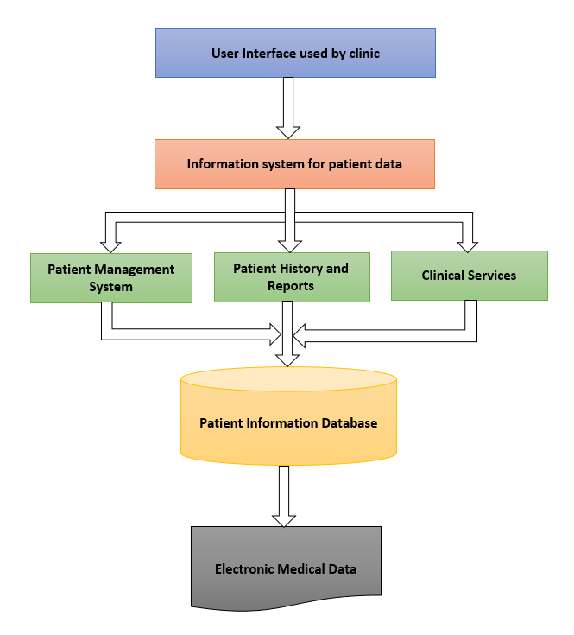

  - Functional Requirements
Functional requirements are features of an application which must be implemented by a development team to enable the end users to accomplish their tasks. Hence, it’s important for the development teams and stakeholders to understand the requirements. Normally, the functional requirements focus on the system behavior under specific conditions.

Functionality:
The functionality of a system is measured by how well that system meets the functional requirements of the stakeholders. The functional requirements exhibit what the system should do without any regard on how they could be done. A list of functional requirements that are deemed to be necessary for ophthalmic healthcare solution system include:
- The system shall cater to both existing and new patients.
- For existing patients, it shall retrieve their existing information.
- The system shall allow the Ophthalmologist/Clinic staff to create new patient profiles.
- The system shall allow the Ophthalmologist/Clinic staff to search/review the records of a specified patient.
- The system shall allow the Ophthalmologist/Clinic staff to update patient information, such as diagnosis, suggested medication, referrals, health conditions, treatments and prescriptions.
- The system shall allow the Ophthalmologist/Clinic staff to schedule appointments for their patients.
- The system shall allow the Ophthalmologist/Clinic staff to view all existing appointments for any selected date.
- The system shall allow the Ophthalmologist/Clinic staff to cancel/reschedule patient appointments.
- The system shall allow the Ophthalmologist/Clinic staff to establish an eye care plan for a specified patient, which includes the identification of short-term and long-term goals based on a patient’s own specific conditions.
- The system shall allow the Ophthalmologist/Clinic staff to upload applicable diagnosis reports or tests to the patient profile.
- The system shall allow the Ophthalmologist to write prescriptions and forward them to the patient’s profile.
- The system shall allow the Ophthalmologist to review the medical prescriptions and health history of a specified patient.
- The system shall allow the patient to review their prescriptions and doctors instructions.
- The system shall allow direct communication between multiple doctors in the clinic associated with the patient.
- The system shall allow the Clinic staff to acquire consent for treatments/surgeries from patients before the scheduled treatments.
- The system shall generate bills and forward them to the insurance company, government agency, and the patient.
- The system shall send emails/text messages to patients’ as an upcoming appointment reminder.
- The system shall collect feedback/survey from patients’ about the service and their experience at the clinic after every visit.

Data:
Data Requirements refer to the type of data, its precision and accuracy, the persistence of data, and the data format. Below, we present some of the ophthalmic healthcare data prerequisites:
- Fixed Data Fields: These fields include the standard attributes that all users share including name, date of birth, address, phone number, email address, sex, and ID.
- Medical Data: This category includes diagnostic and treatment data using both medical codes and text.
- Sensors Data: This data represents the readings from various sensors, such as temperature, blood pressure, and blood sugar level.
- Image Data: Under this category, various images are stored, such as X-rays.
- Accounting Data: This data provides all the fields needed for producing bills and invoices.
- Service Data: Includes data needed for government agencies.

  - Performance Requirements

NFR_003 | Performance
Justification | Ophthalmologists and clinic employees using the system for any of their daily activities like booking appointments, treatment and diagnostic history, payments, insurance claims etc.
Accepted Measurement | System response time should be minimum
Limitations | Maintaining data consistency and availability simultaneously might affect the performance of the system
Action Plan | - Response time of the request should be less than 250 milli seconds  - Implementing cache for faster results  - Transactions and requests should be faster than requests for analytical data

  - Software System Attributes

These are the properties or qualities that the system must have. They specify the system’s ‘quality characteristics’ or ‘quality attributes’. They are specific criteria that is used to judge the operation of a system, rather than specific behaviors of the system.

    - Availability

NFR_001 | Availability (System Downtime)
Justification | - Frequent data backups  - Upgrading and updating the system
Accepted Measurement | Downtime should not affect the regular business hours
Limitations | Synching downtime with multiple time-zones across the country
Action Plan | - System should be monitored for user activity  - System maintenance should be carried out during least activity slots
    - Security

NFR_004 | Security
Justification | Data exchange and storage between the system and the users
Accepted Measurement | - Data accessibility should be based on the roles of the users  - System involves sensitive patient information which should be shielded across the role hierarchy  - Approved HIPAA evaluation of a compliance program
Limitations | Security requires minimizing the number of copies of the data (Availability), this reduces the chance of intruders accessing the data. Therefore, there is a fundamental architectural conflict between availability (replication, several copies) and security (specialization, minimal copies).
Action Plan | - HIPAA Privacy Rule to outline the right of the patient to access patient health information, a healthcare provider’s right to decline access of the PHI.  - HIPAA Security Rule for secure handling, maintenance and transmission of the protected health information of the patients  - Information in a system shall not be disclosed or made accessible to people or programs that are not authorized to have access to that information  - When an application is created, developers must continually monitor, fix and prevent security vulnerabilities  - Data requests and transfers should be encrypted

    - Data Consistency

NFR_002 | Consistency
Justification | Ophthalmologists and clinic employees updating the system for any of their daily activities like booking appointments, treatment and diagnostic history, payments, insurance claims etc.
Accepted Measurement | Data should be consistent in every device and for every user
Limitations | - Maintaining multiple servers for better system performance and availability may lead to data inconsistency  - Unverified and non-validated data will lead to data inconsistency
Action Plan | - The data should be verified and validated before the user performs submit action  - The data consistency should be monitored across the servers by the experts

    - Scalability

NFR_005 | Scalability
Justification | Large number of system users
Accepted Measurement | System should be designed in a way that it can be scaled to accommodate the expanding user base in future
Limitations | - Complicated system architecture  - Changes in the development team post product release  - Resources involved to scale the system might not be compatible with the old system
Action Plan | - Systematic and simplified architecture  - Well-communicated teams  - Implementing microservice approach

  - Functional Hierarchy

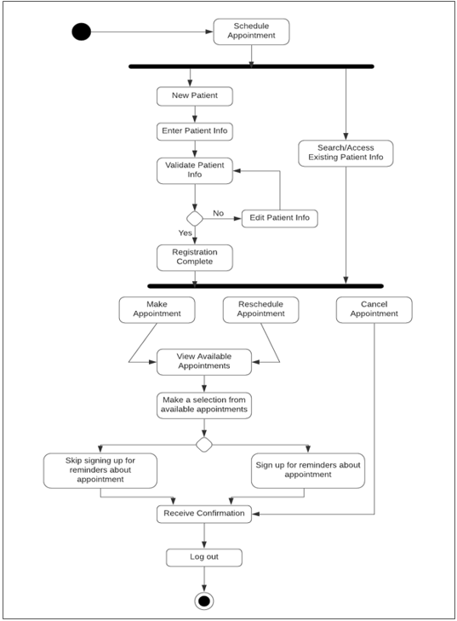

  - Requirements Validation
The test plan serves as a blueprint to conduct software validation activity. The plan identifies the items to be validated, the features to be tested, the types of testing to be performed, the resources and schedule required to complete testing, and the risks associated with the plan.

Scope:
Feature to be tested
All the features of Vision2020 which were defined in the Functional Requirements section above are to be tested.
Feature not to be tested
Features like User Interfaces, Hardware Interfaces, Software Interfaces, Database logical, Security and Performance need not be tested.

Test Type
In Vision2020 project, we have the following levels of testing:
- Unit testing:
The individual units/components of a software are tested. The purpose is to validate that each unit of the software product performs as expected.
- Integration testing:
Here, the individual units/components are combined and tested as a group. The purpose of this level of testing is to expose faults in the interaction between integrated components.
Bottom-up integration testing approach is used where the integration begins from the lowest level modules. We use test drivers to drive and pass required test data to the lower level modules and as and when the code for the other module are developed, these drivers are replaced with the actual module. The purpose of this level of testing is to expose defects during the interaction when all the components are integrated.
- System Testing:
This testing level validates the complete and fully integrated software product. The purpose of a system test is to evaluate the end-to-end system specifications. It is also necessary to test the non-functional aspect of the system which include tests to check performance, data security, usability/user friendliness, volume, and load/stress.

- Change Management Process

The following template will be used to identify, log, evaluate, and update the SRS to reflect changes in project scope and requirements. When new change requirements come in, the project manager communicates these approved requirements to the development team, who take forward the development activity to reflect the changes to the system.

Change Management Process:
- Request for change is made
- Register and assess the change
- Review and submit request form to Change Board
- Change Board accept or reject the change
- Update plans & implement the change

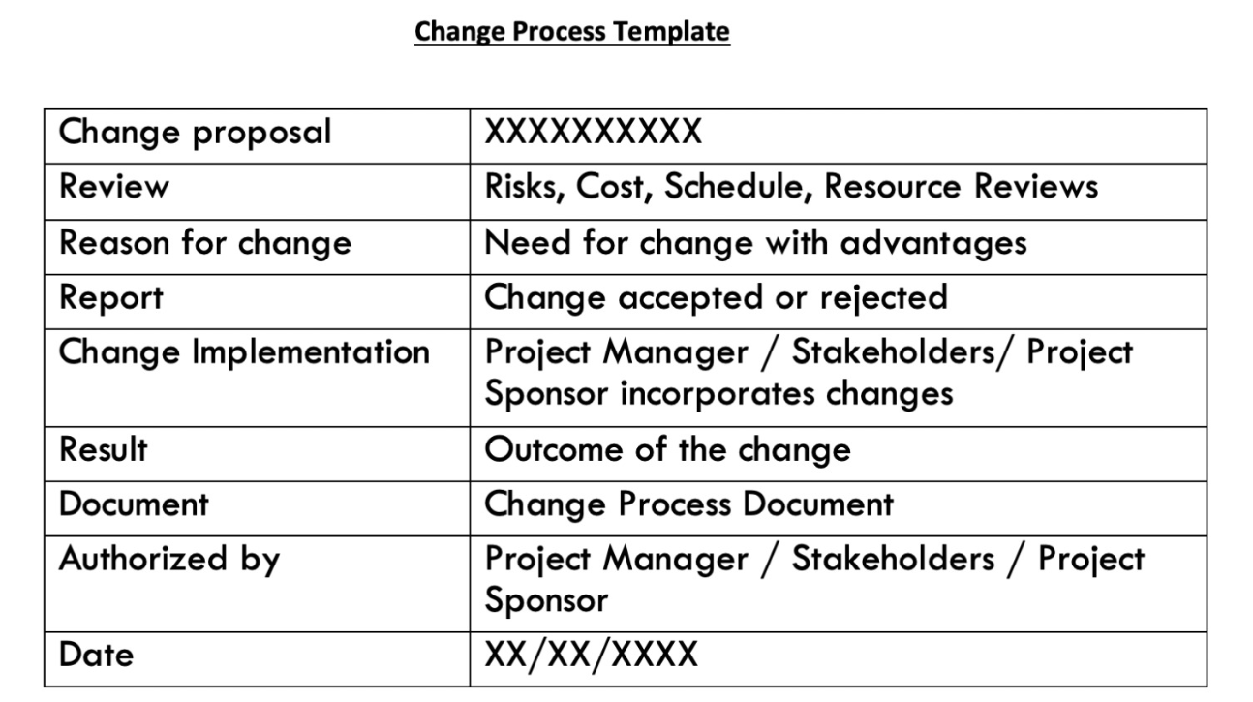

- Document Approvals

Project Manager is responsible for the approval of this SRS document.

